*This Website project continues throughout this course and will be graded twice (midterm and final). You will be given instructions to build the website along with what you have learned for the week.  Stay on top of this project!  This is a weighted project worth a total of 50% of your grade.*

A small art and photography studio has asked for your help in creating a website that show the artworks, scheduled events, and to provide contact information for submissions/contributions. A site map shows how the website will be organized and it defines the structure of a website.

This wire frame sketch shows the page layout for the website.

header

nav

main

div

footer

A wireframe sketch gives you a visual diagram that outlines the structure and layout of a website. Consider it your blueprint to help you plan the content hierarchy and functionality of the website before detail is added.

STEP 1 – Create a folder called <lastname> ArtWorks. This will hold all of your website files.

STEP 2 – Create the Homepage using a text editor as shown on next page. In your text editor, create a HTML web page with the following:

1. Add a Web page title element in the head element: Welcome to ArtWorks
2. Code the header element within an h1 heading element with the text: ArtWorks Studio
3. Create the navigation. Place the following text in the nav element with bold <b> element: Home The Art Events Contact Your links (anchor tags) to each page are index.html; art.html; events.html; and contact.html respectively. Add extra blank spaces between hyperlinks using the &nbsp; special character.
4. Create a main element. Add h2 element with the text: Our Studio. Add a paragraph element with the text: Our mission is to provide a place to showcase community-based art and photography. We hope to

Next, configure an unordered list with the following content:

* enhance your artistic growth
* promote creative practice
* and encourage local collaboration

Add within a div element the following address and phone number using line break tags configure the area and add extra space between the phone number and the footer.

1. Create a Footer element, formatted with small text (<small></small>) and italics font style (<i></i>) with the following text:

©2025 Blue Ridge Community and Technical College

[*yourfirstname*@*yourlastname*.com](mailto:yourfirstname@yourlastname.com)

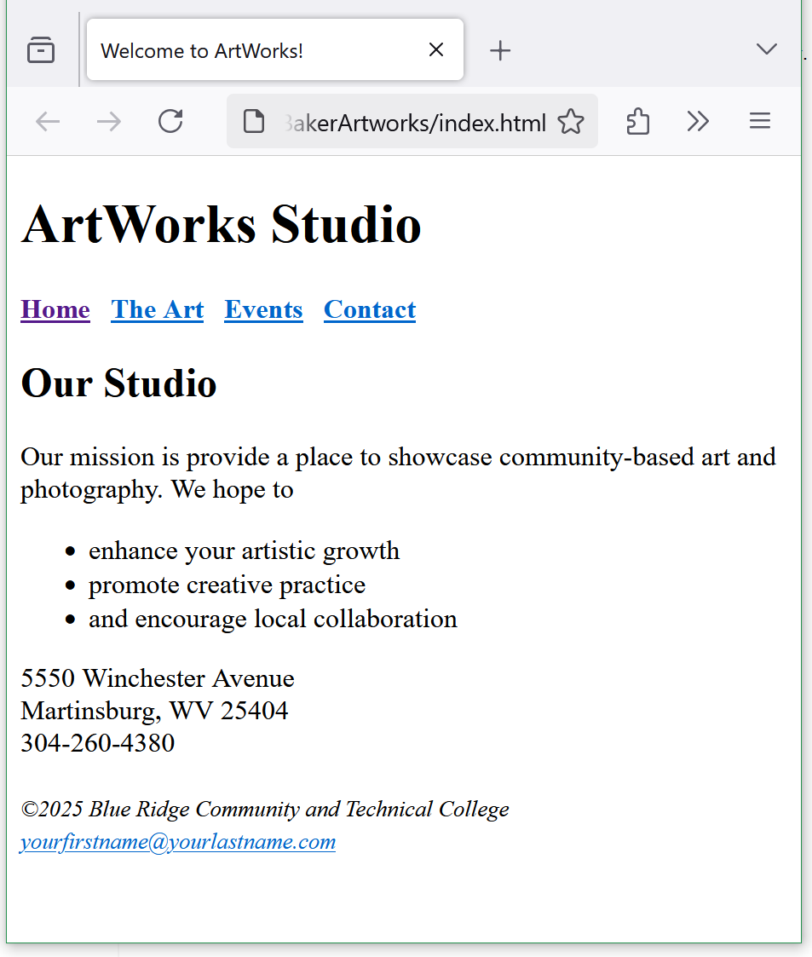

STEP 3 – Create the The Art page as shown below. You can copy portions of the index page that are duplicated on this webpage. With the index page open in your text editor, do a “save as” and save the file with the new file name art.html into your Artworks website folder. Edit the following:

1. Change text of title element to: ArtWorks | See the Art
2. Within the Main content area, delete the paragraph, unordered list, and div elements.
3. Change the heading 2 element text to: Types of Works
4. Use a description list element to configure the following information:

Creative Art

Include visual forms of expression such as painting, drawing, sculpture, and digital art, etc. that can be displayed in our gallery and presented on our website.

Creative Photography

Images that combine different shapes, colors, and forms of ordinary moments and are transformed into creative art using a camera and editing software.

Add strong importance using the strong tags for each term(name).

HINT: be sure to use all elements for a description list (list, term(name), and description tags.)

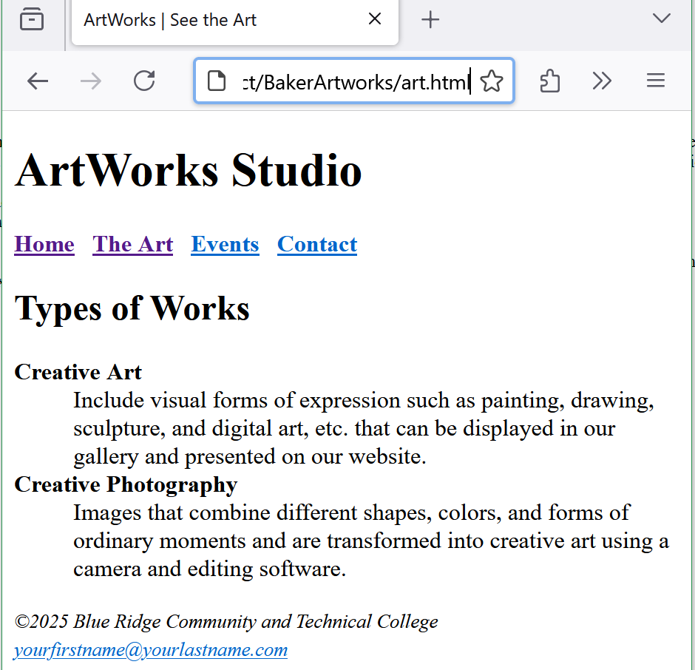

Save your website files and test the site in a browser. Verify the folder name, file names, and all content are punctuated and spelled correctly.

This project is on going and will first be submitted at midterm for grading. You will receive additional building instructions up until then and after midterms, you will continue to build upon the site with the complete project submitted during finals.

Contact your instructor, with any questions regarding these directions.